HARROW COUNCIL

SUPPLEMENTAL ADDENDUM

PLANNING COMMITTEE

DATE: 15th February 2023

2/01 | Ref: P/3350/22 – 24 Dryden Road  Additional slide for Powerpoint presentation  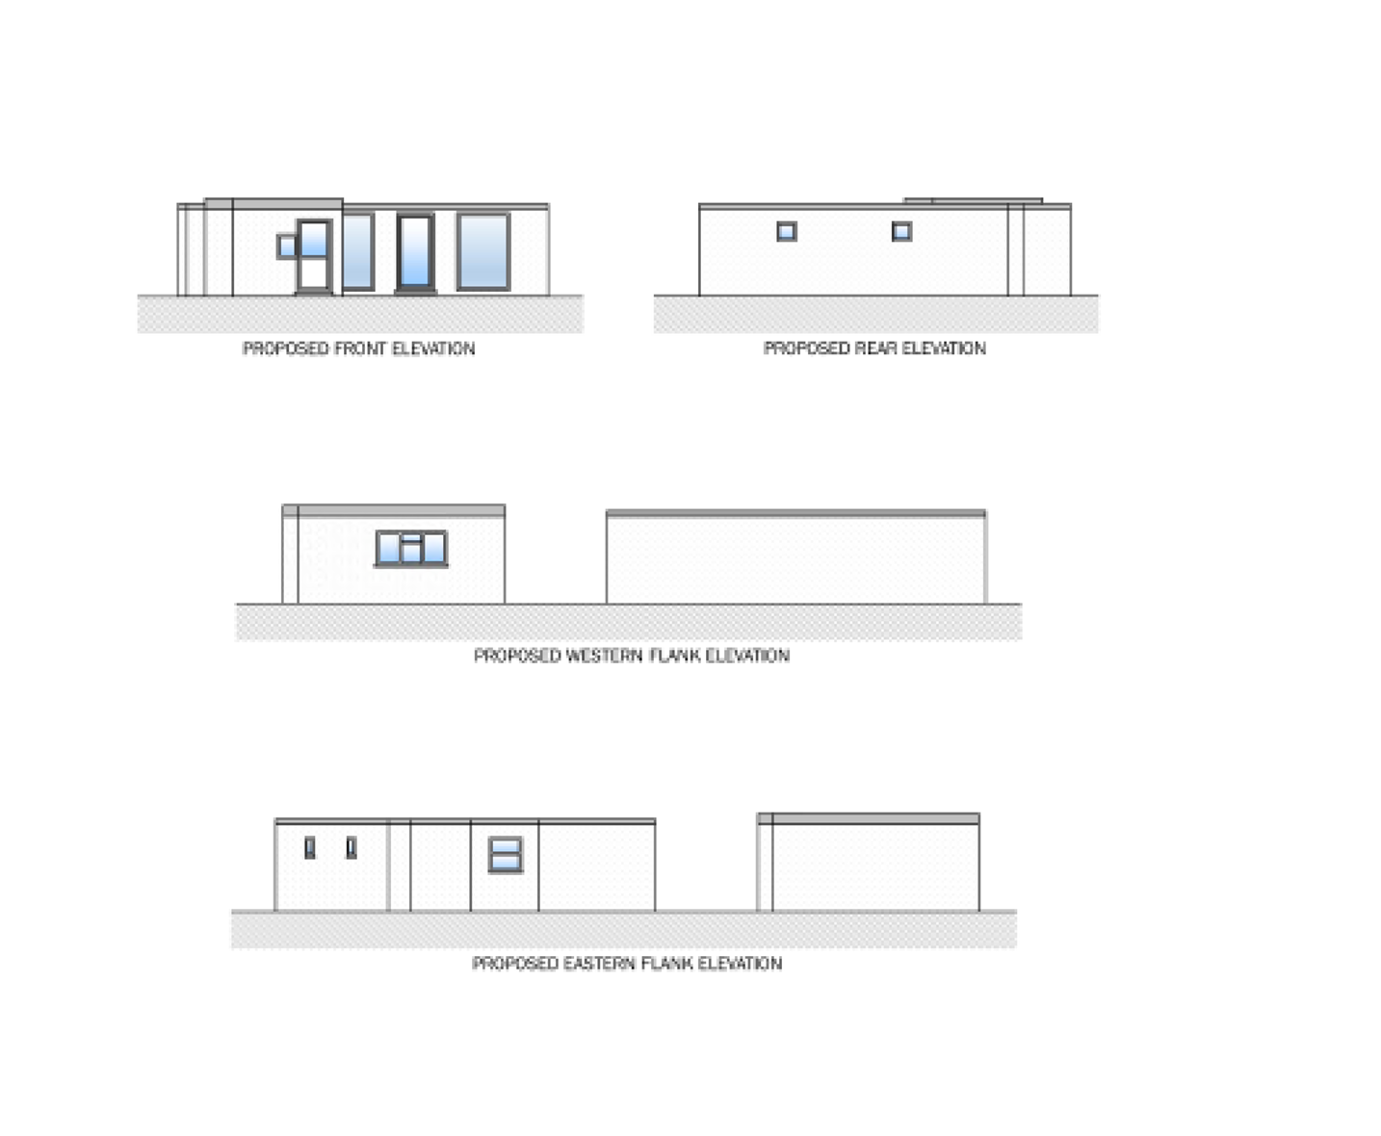
2/03 | 272 High Road – P/0569/22
Item 1 | Two additional conditions have been added  Restricted Use  The development hereby approved for the ground floor unit at the front of the property shall be used for the purposes of a Shop other than hot food [Use Class E(a)], Financial services [Use Class (E(c)(i)], or Professional services (other than health or medical services [Use Class E(c)(ii)], or other appropriate services in a commercial, business or service locality [Use Class E(c)(iii)], and for no other purpose (including any other purpose in Class [E] in the schedule to the Town and Country Planning (Use Classes) Order 1987 (as amended), the Town and Country Planning (Use Classes) (Amendment) Regulations 2020 or changes of use as permitted by the Town and Country Planning (General Permitted Development) Order 1995 (as amended).  Reason: To enable the Local Planning Authority to control the use of the site and because other uses would be contrary to policies CS1(A)(B)(C)(l)(M)(P) of the Harrow Core Strategy (2012), and Policies DM1(A)(B(c,f)(C)(D)(H)(I) and DM2(Aa), DM4, DM37, DM38, DM42, DM44 and DM45 of the Development Management Policies Local Plan (2013) and the adopted Supplementary Planning Document entitled ‘Residential Design Guide’ (2010) and guidance contained within the National Planning Policy Framework (2021).  Operational Hours  The [E(a)(c)] premises (ground floor unit at the front of the property) shall not be open for trade or business except between the hours of 06.00 to 23.00 and there shall be no external illumination of the premises except between these hours.  Reason: To safeguard the amenities of neighbouring properties in accordance with Policies DM1(A)(B(c,f)(C)(D)(H)(I) and DM2(Aa), DM4, DM37, DM38, DM42, DM44 and DM45 of the Development Management Policies Local Plan (2013) and the adopted Supplementary Planning Document entitled ‘Residential Design Guide’ (2010) and guidance contained within the National Planning Policy Framework (2021).
Item 2 | Committee report will need to be updated with insertion of below Paragraph  An additional Paragraph (6.4.10) will need be included within the report; -  Officers have taken into consideration the proposed commercial use for the ground floor of the mixed-use building and how it fits with the existing residential units, and it is deemed that this use is compatible with the residential units above and nearby. Notwithstanding the above, two conditions are to imposed so to ensure the new use of the commercial unit is to remain strictly within the intended planning Use Classes of E(a) to (c) with their hours of operation also being limited to set times and days of the week, this in the interest of safeguarding the amenities of the residential units located above and at the ground floor rear of the building, as well as preserving the character and appearance of the locality and how it functions, such uses are not considered to have any detrimental impacts by virtue of noise disturbance, odours, traffic, crime and safety, or visual amenity and the way the area functions. Any other potential uses within Class E, would require further assessment and consultation, thus be subject to a fresh planning application.  Conditions List within the Committee report will need to re-numbered accordingly with above additional conditions and correct duplicated numbering.
AGENDA ITEM 10 – REPRESENTATIONS ON PLANNING APPLICATIONS

Agenda Item |  | Application | Speakers
2/01 |  | 24 Dryden Road, Harrow (P/3350/22) | Simon Joshua (Objector)  Mohammad Hasan (Agent for Applicant)

